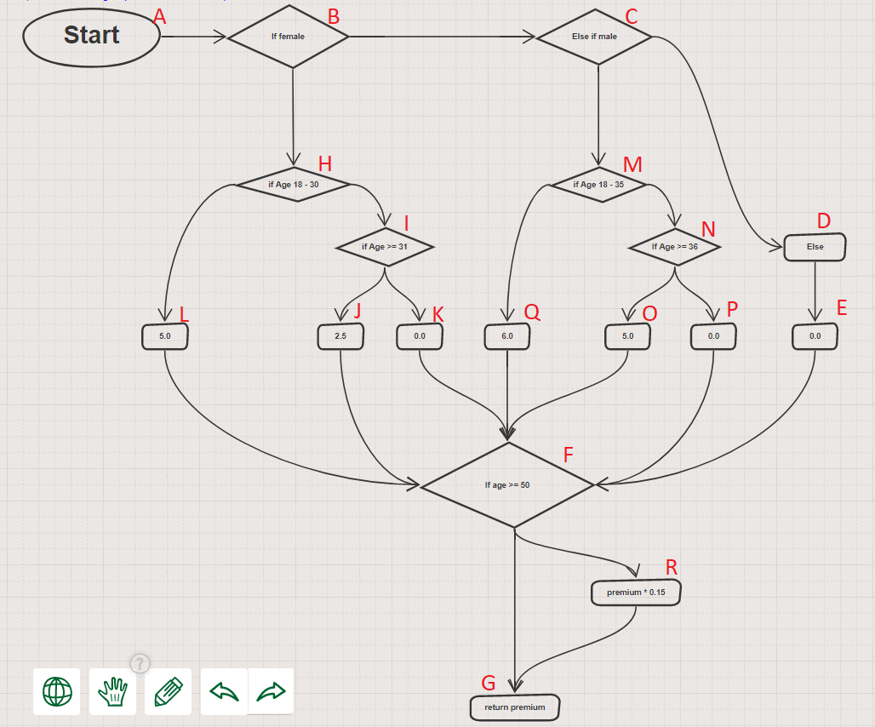

All Paths:

1-ABHLFRG

2-ABHLFG

3-ABHIJFRG

4-ABHIJFG

5-ABHIKFRG

6-ABHIKFG

7-ABCMQFRG

8-ABCMQFG

9- ABCMNOFRG

10- ABCMNOFG

11- ABCMNPFRG

12- ABCMNPFG

13-ABCDEFRG

14-ABCDEFG

Cyclomatic Complexity:

m = E – n + 2

m = 24 – 18 + 2

m = 6 + 2

m = 8

